**Project Design Phase**

**Problem – Solution Fit Template**

|  |  |
| --- | --- |
| **Date** | 23/06/2025 |
| **Team ID** | LTVIP2025TMID31079 |
| **Project Name** | Medical Inventory Management |
| **College name** | IDEAL INSTITUTE OF TECHNOLOGY, KAKINADA |

**Problem – Solution Fit Template:**

**Problem:**

Healthcare facilities often struggle with manual inventory management, which leads to:

* Stockouts of critical medicines and supplies.
* Overstocking and expired items due to lack of real-time tracking.
* Human errors in tracking and reporting inventory levels.
* Inefficient reporting causing delays in procurement and decision-making.
* Compliance issues due to poor documentation and mismanagement.

**Proposed Solution:**

Develop a Medical Inventory Management System that:

* Provides real-time tracking of medicines and medical supplies.
* Sends automatic alerts for low stock and nearing expiration.
* Generates accurate reports for better planning and auditing.
* Offers user-friendly dashboards for inventory visibility.
* Integrates with procurement processes to enable timely reordering.

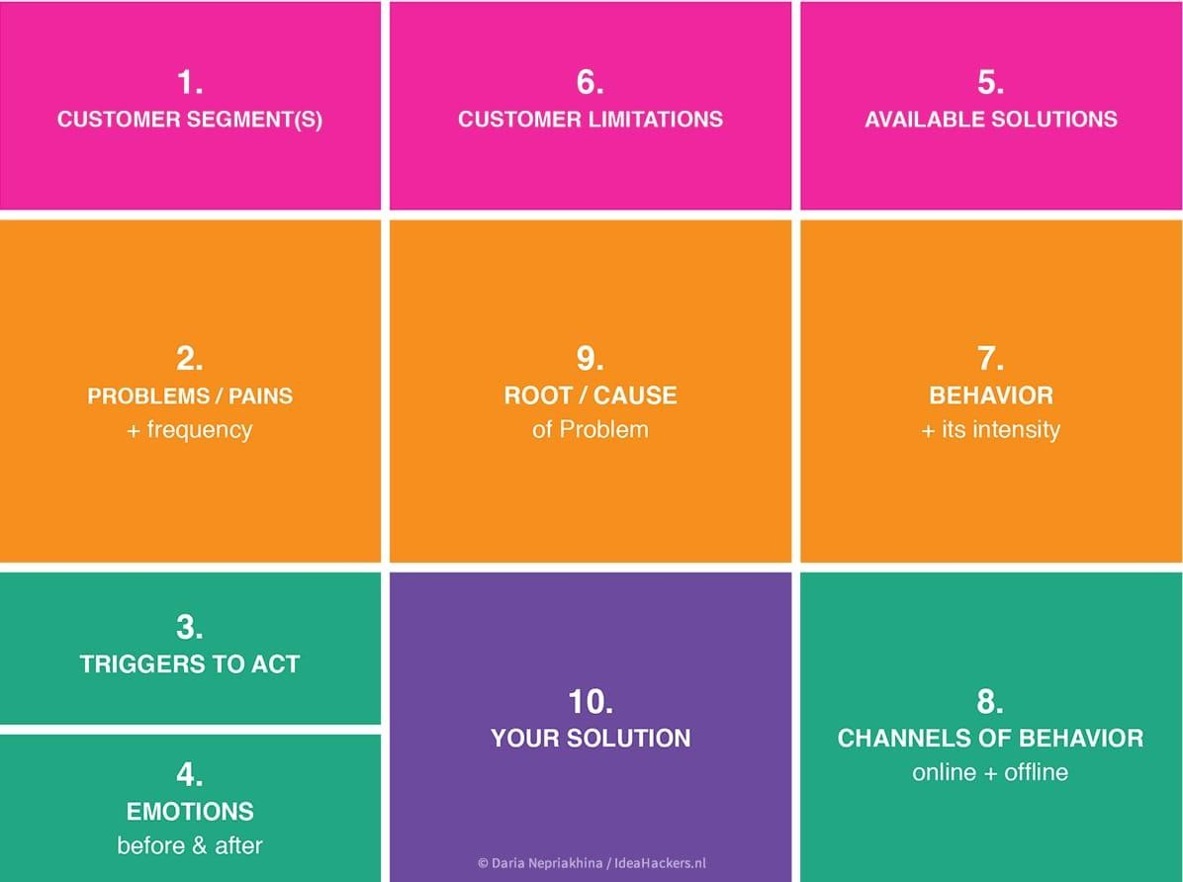

**Solution Architecture:**

The Medical Inventory Management System is designed with multiple layers:

* User Layer: A web or mobile app that allows admins, inventory managers, and medical staff to track stock, receive alerts, and place orders.
* Application Layer: Handles all inventory operations, user management, reporting, and system notifications.
* Data Layer: Stores all inventory data, including stock levels, expiry dates, and transaction history in a centralized database.
* Integration Layer: Connects the system to suppliers, procurement platforms, and barcode/RFID scanners.
* Notification Services: Sends low-stock, expiry, and order alerts via SMS, email, or inapp messages.
* Security Layer: Ensures secure access, data protection, and compliance with healthcare regulations.

This structure provides a smooth, efficient, and secure way to manage medical inventory in healthcare facilities.

